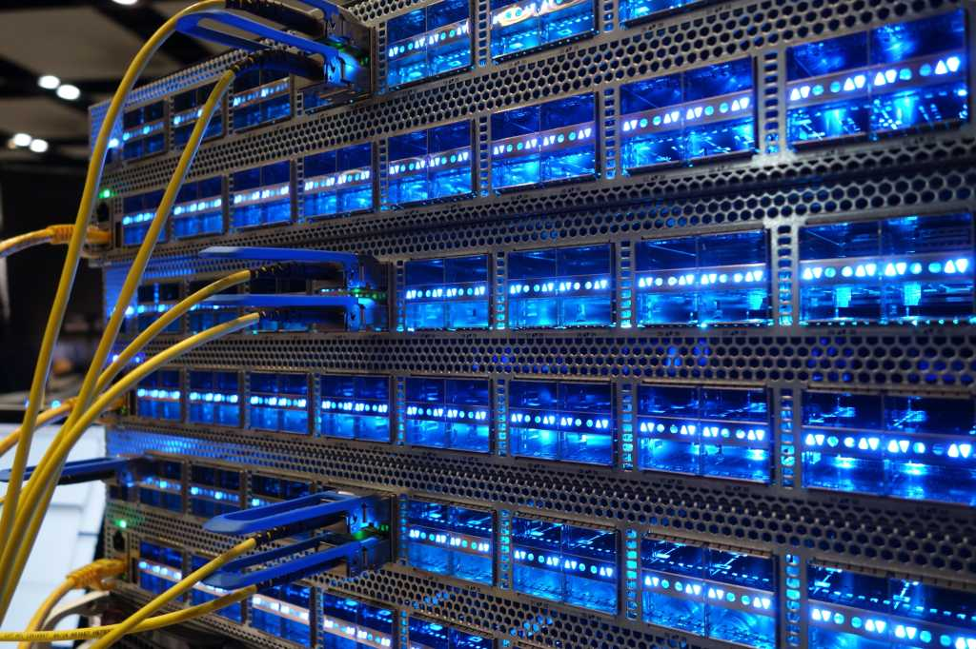
AWS Academy Cloud Foundations: Configuring Elastic Block Store, Relational Database Service, and Elastic Cloud Compute Auto Scaling

Gio Hua, CCNP

Purpose:
This write-up explains the fourth, fifth, and sixth lab from the AWS Cloud Foundations course. In these labs,
Background:
Lab Summary:
Lab Commands:

Elastic Block Store (Lab 4):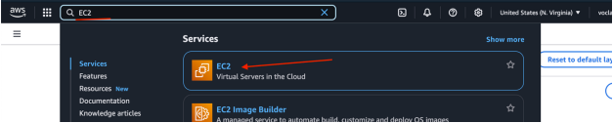
From the AWS search bar, type in and launch “EC2”.

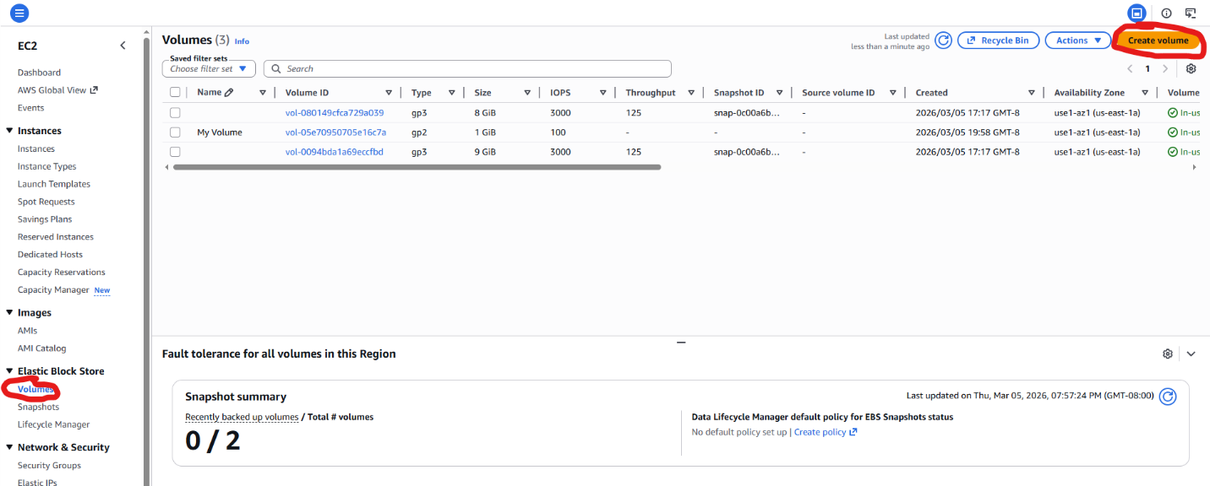
Go to the “Volumes” section and click “Create Volume”.
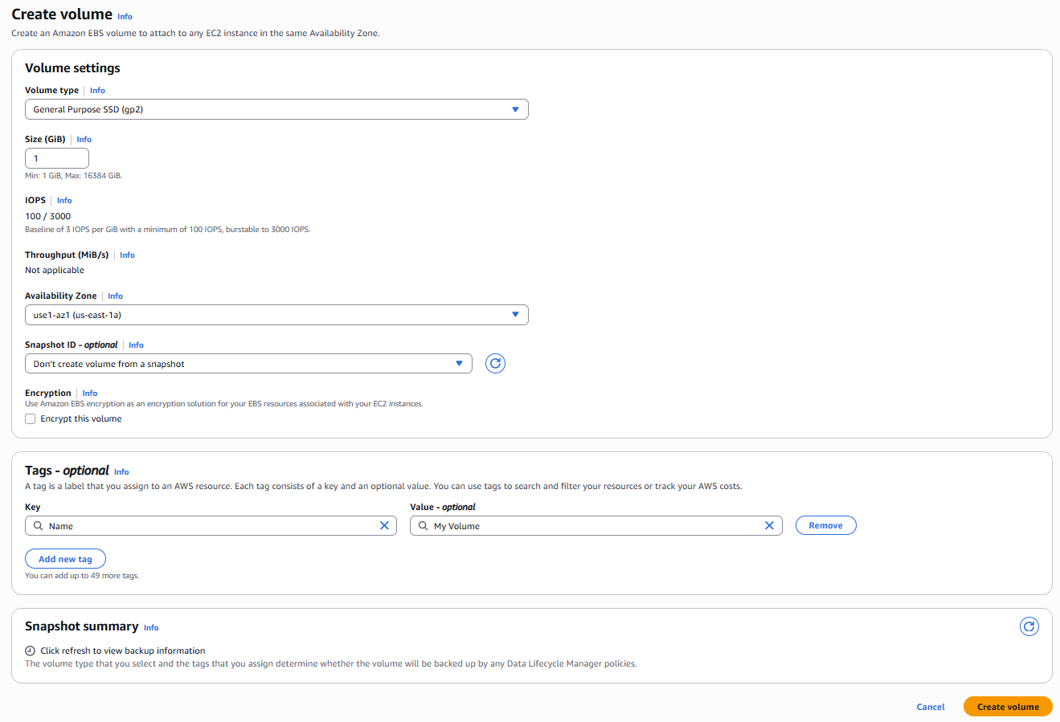
Set the volume type to “gp2”, the size to 1 gigabyte, and the availability zone to the same zone as the Lab instance.

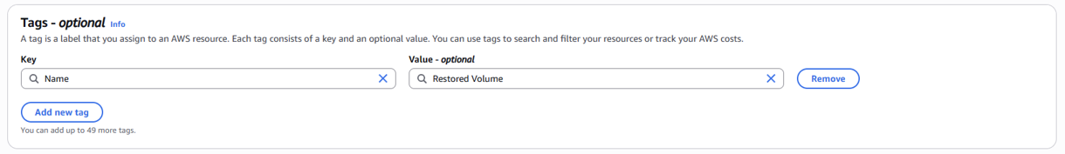
Under “Tags”, click “Add Tag”. Set the key to “Name” and the value to “My Volume”. Then click “Create Volume”.

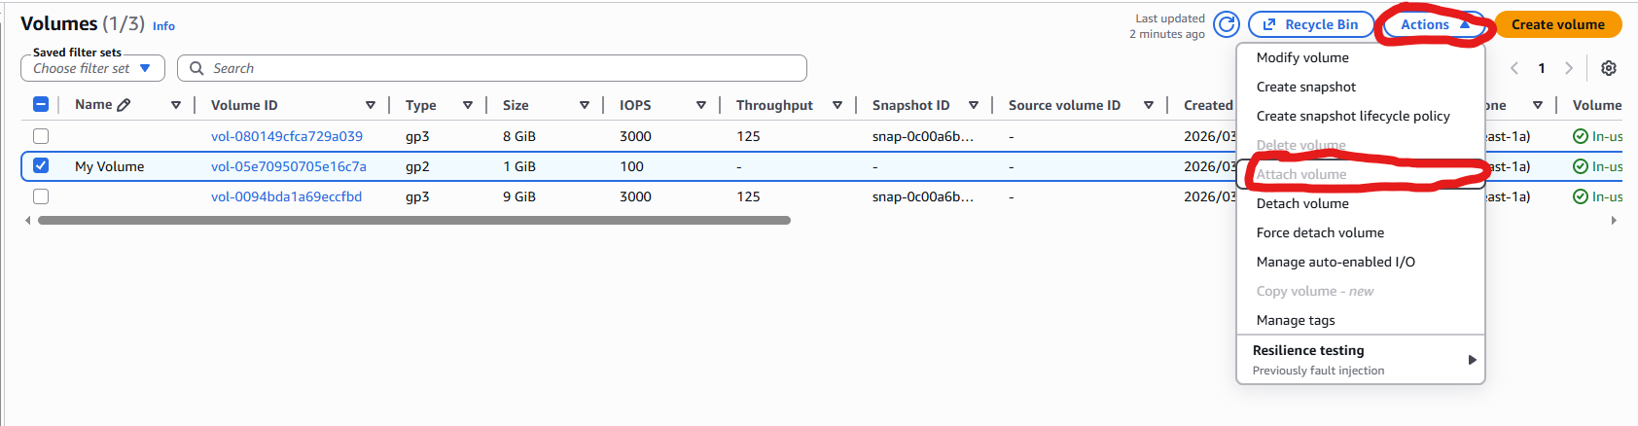
You should now be redirected to the Volumes page. Click the checkbox next to My Volume, then under Actions, click Attach Volume.

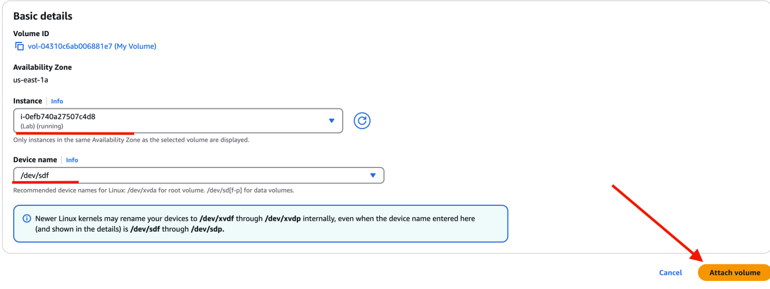
Set the instance to the Lab instance and the device name to /dev/sdf, then click Attach volume.

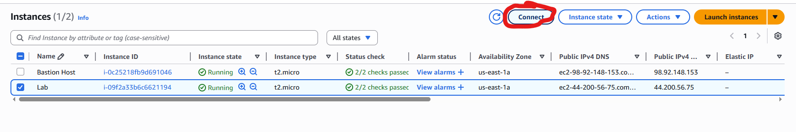
Go to the “Instances” section, click the checkbox next to “Lab”, and click “Connect”.

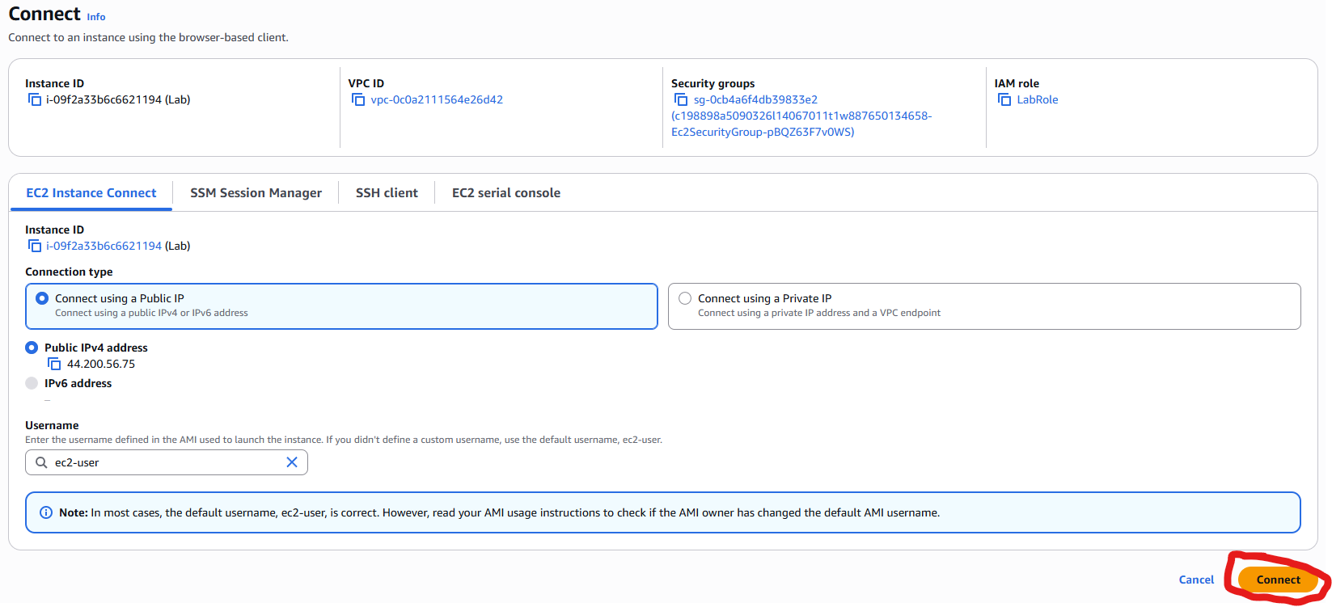
Select “EC2 instance connect”, select “Public IPv4 address”, then click “Connect”.

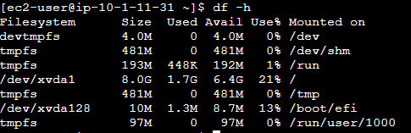
Run the command df -h to list the mounted volumes.

Run the command sudo mkfs -t ext3 /dev/sdf to create an ext3 file system on the volume you created.

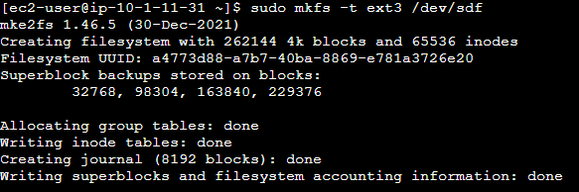
Run the command sudo mkfs -t ext3 /dev/sdf to create an ext3 file system on the volume you created.

Run the command sudo mkdir /mnt/data-store to create a new folder at /mnt/data-store.

Run the command sudo mount /dev/sdf /mnt/data-store to mount your volume at the created folder.

Run the command echo "/dev/sdf /mnt/data-store ext3 defaults,noatime 1 2" | sudo tee -a /etc/fstab to add this mount binding to /etc/fstab, a file that automatically mounts volumes at startup.

Run the command cat /etc/fstab to confirm that the line was added.

Run the command sudo sh -c "echo some text has been written > /mnt/data-store/file.txt" to create a file with the text “some text has been written” at the specified location.

Run the command cat /mnt/data-store/file.txt to confirm that the file was written.

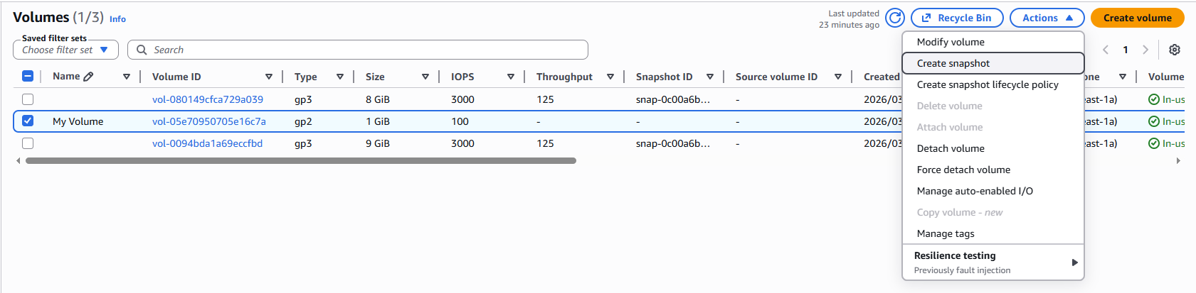
Go back to the main AWS console tab. Under Volumes, check My Volume, then click Actions > Create Snapshot.

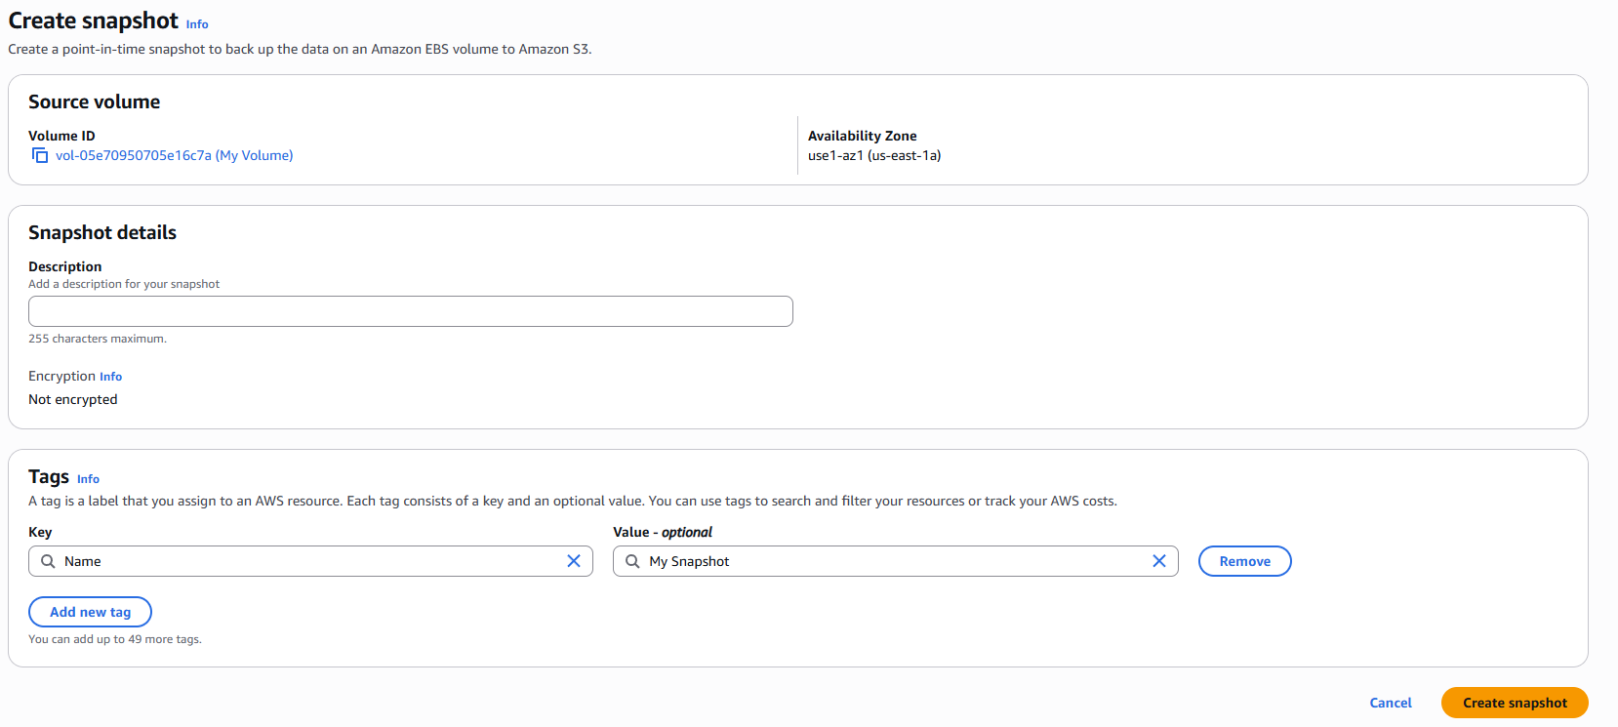
Under Tags, click Add Tag, set the key to Name, set the value to My Snapshot, then click Create Snapshot.
Switch back to the console and run the command sudo rm /mnt/datastore/file.txt to remove the file you created earlier.

Run the command ls /mnt/data-store to confirm that the file has been deleted.

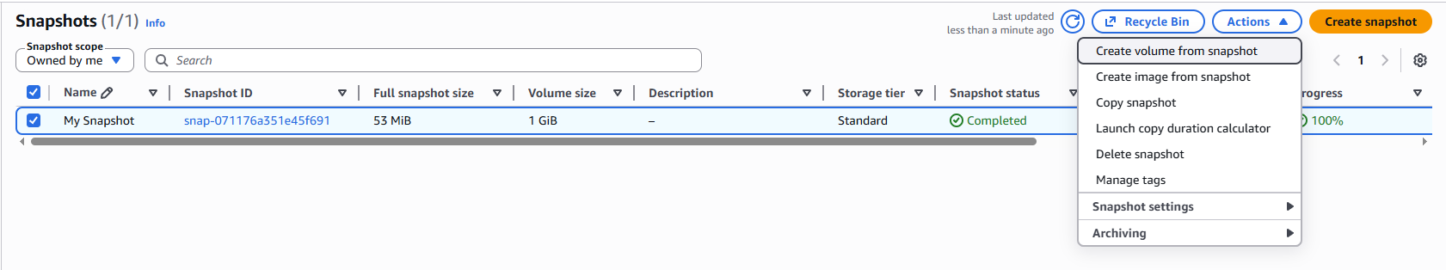
Back in the AWS console, go to Snapshots > Check My Snapshot > Actions > Create volume from snapshot.

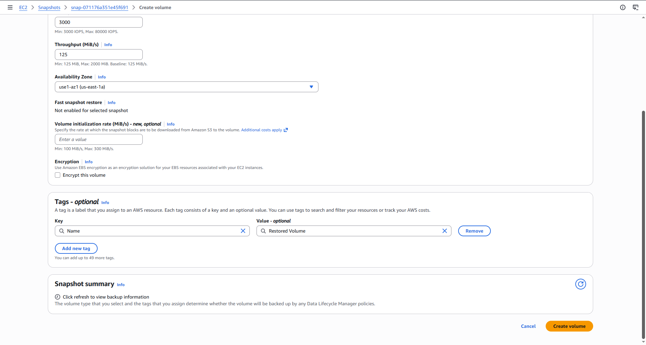

Set the volume type to gp2, then click Add Tag, set the key to Name, set the value to Restored Volume, then click Create Volume.

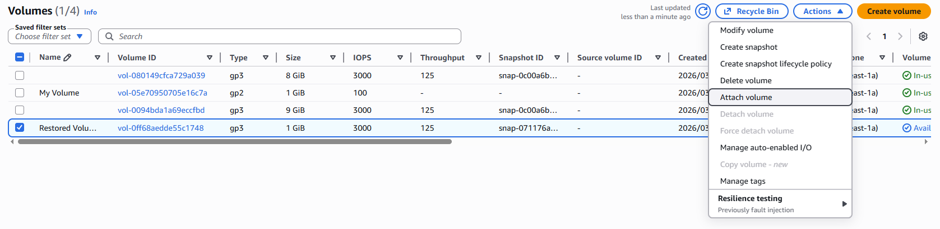
Under Volumes, check Restored Volume, then click Actions > Attach Volume

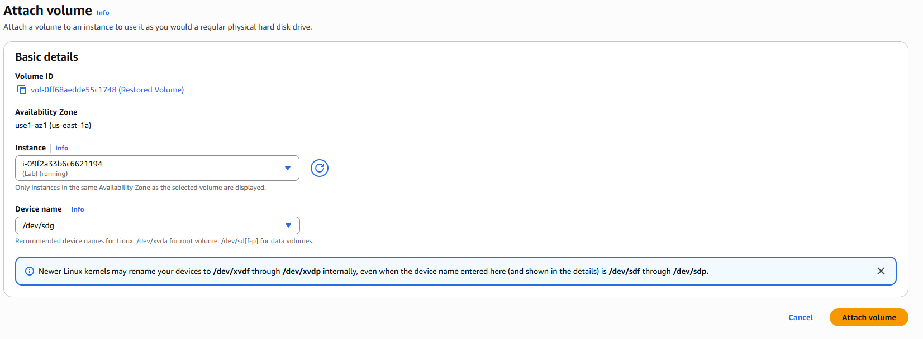
Set the instance to Lab, the device name to /dev/sdg, then click Attach Volume.

Run the command sudo mkdir /mnt/data-store2 to make a new folder for the restored drive.
Run the command sudo mount /dev/sdg /mnt/data-store2 to mount the restored volume at the specified point.
Run the command ls /mnt/data-store2/ and ensure that file.txt shows up.
Relational Database Service (Lab 5):
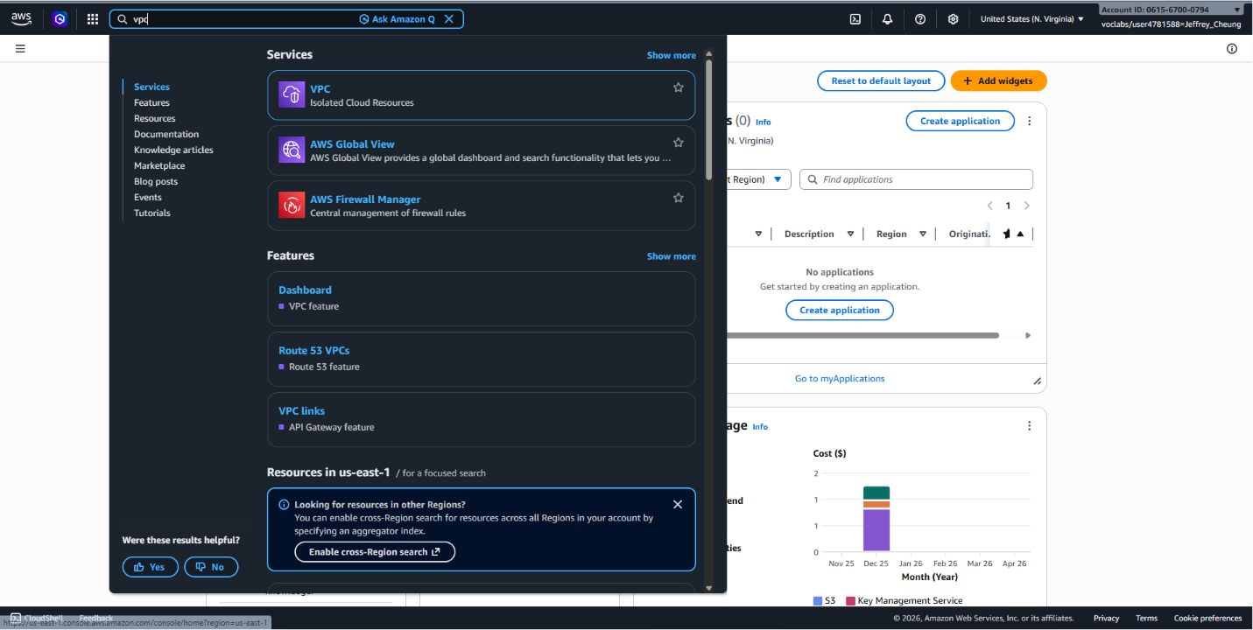
From the AWS console search bar, open VPC.
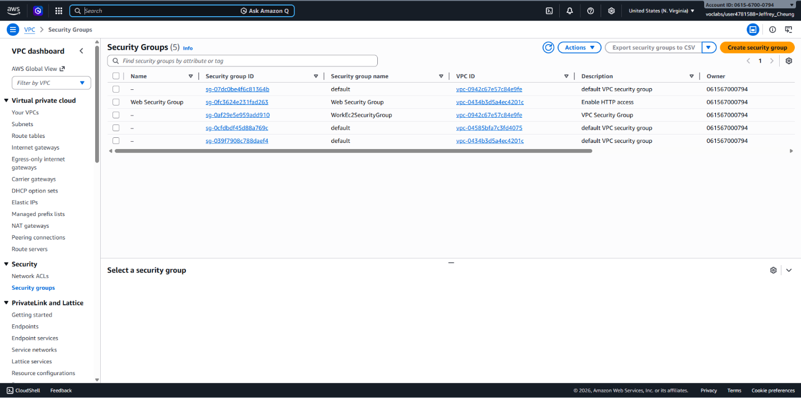
Under Security Groups, click Create Security Group.
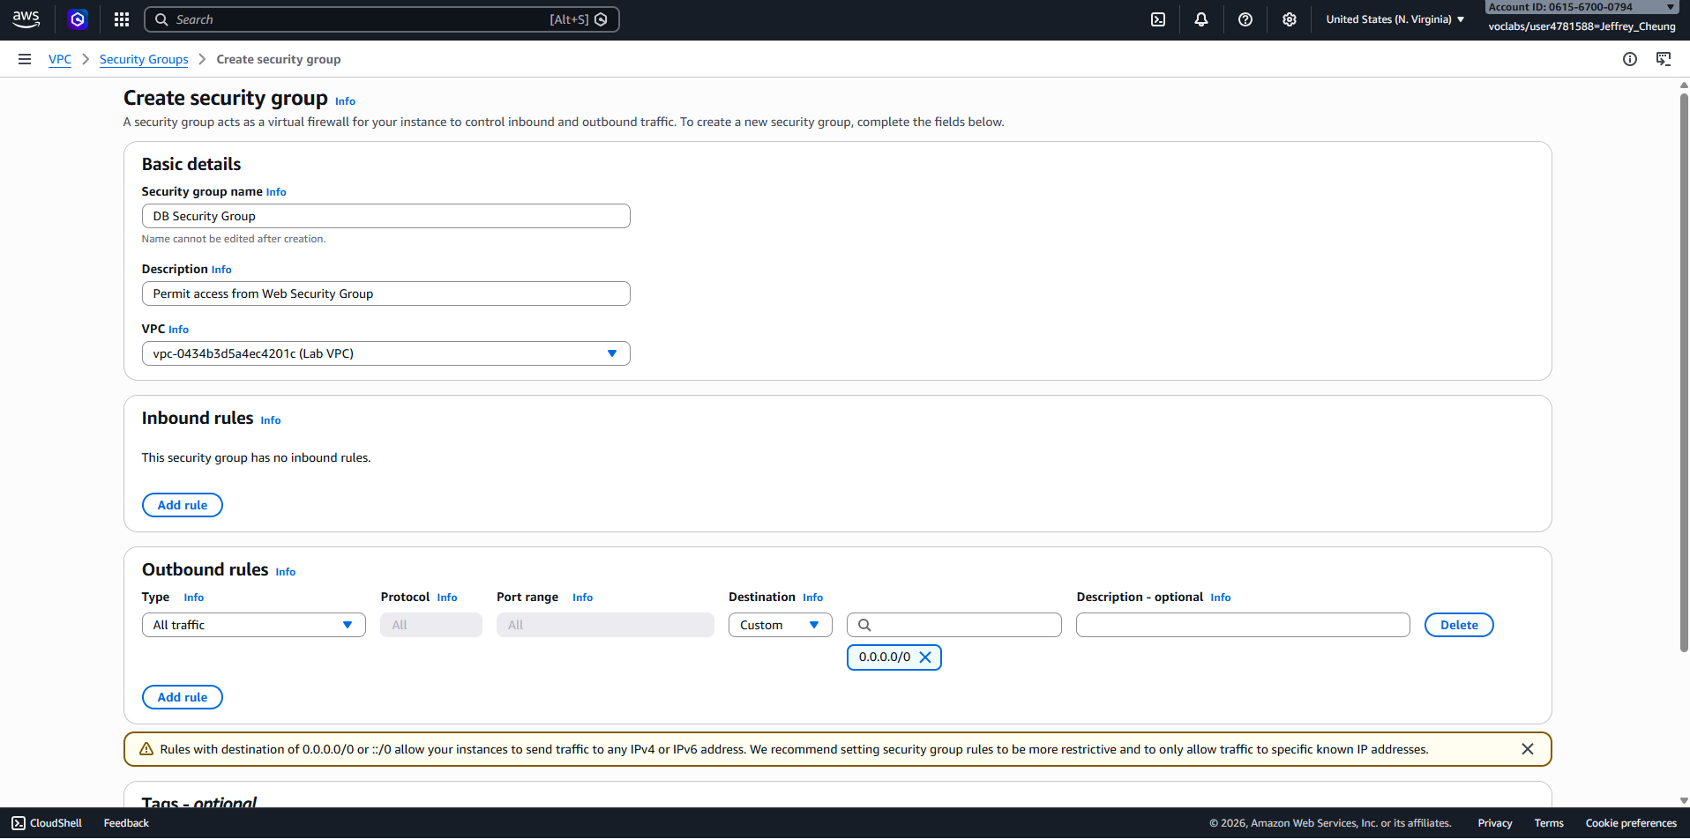
Set the name to DB Security Group, the description to Permit access from Web Security Group, and the VPC to Lab VPC. Under Inbound Rules, click Add Rule, set the type to MySQL/Aurora, and set the source to the Web Security Group. Click Create security group.
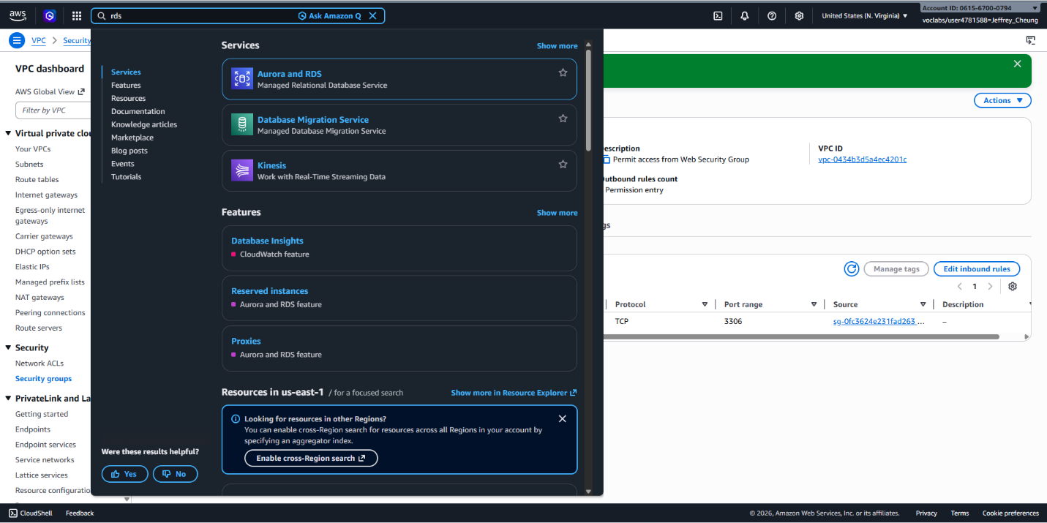
Go to RDS from the search bar.
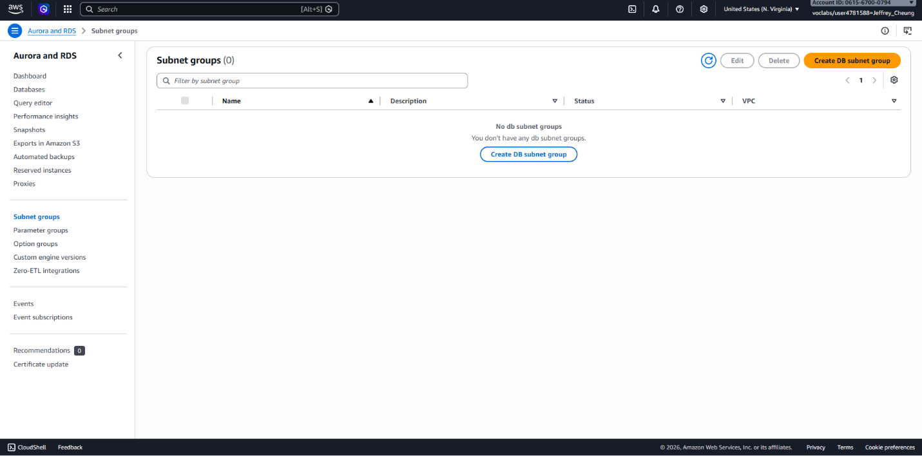
Go to Subnet groups > Create DB Subnet Group.
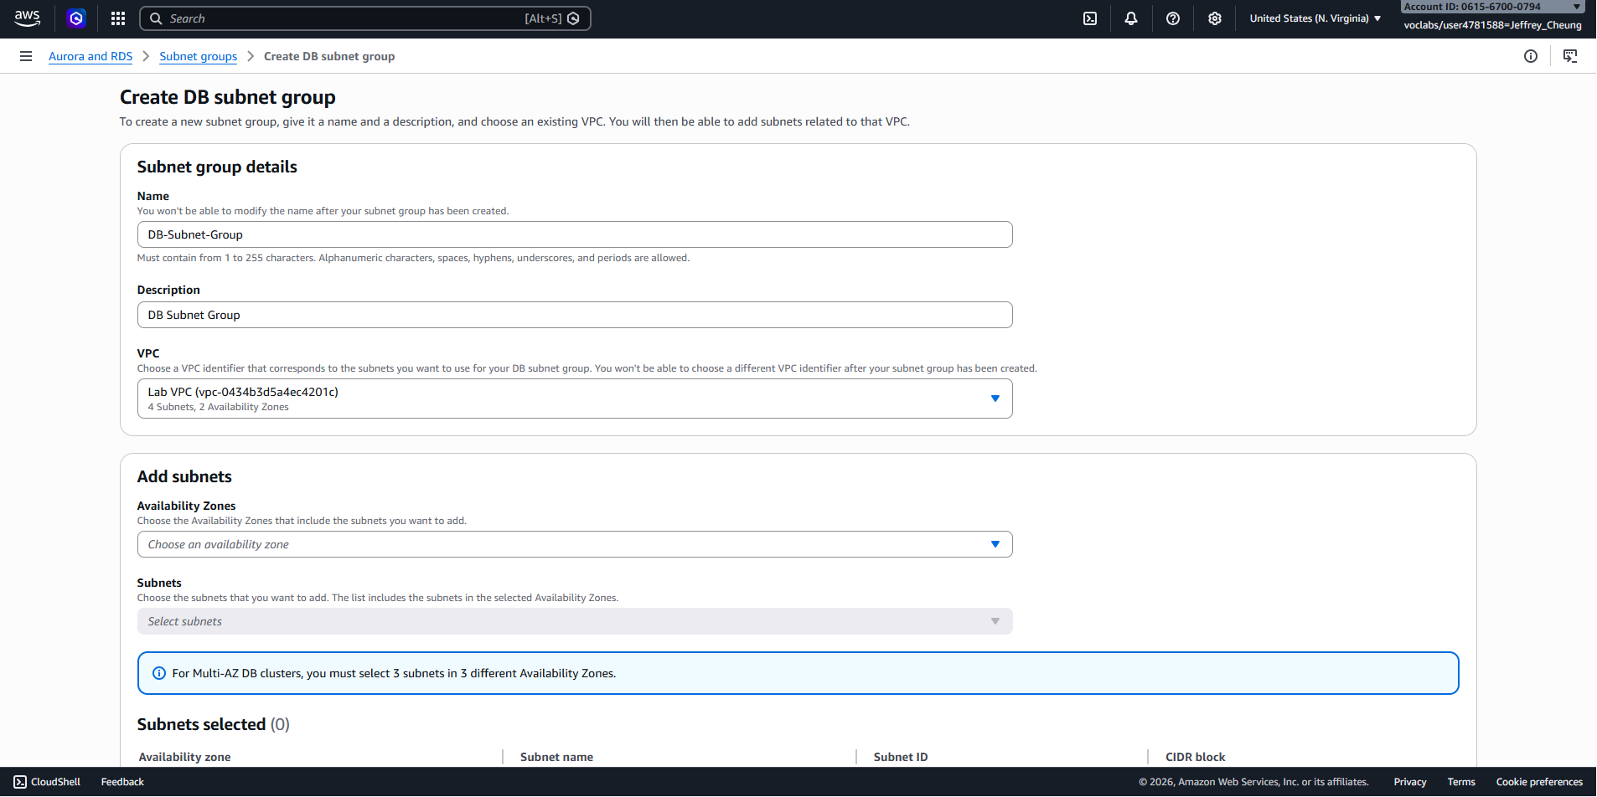
Set the name to DB-Subnet-Group, the description to DB Subnet Group, and the VPC to Lab VPC. Set the availability zones to us-east-1a and us-east-1b, and set the subnets to Private Subnet 1 and Private Subnet 2. Click Create.
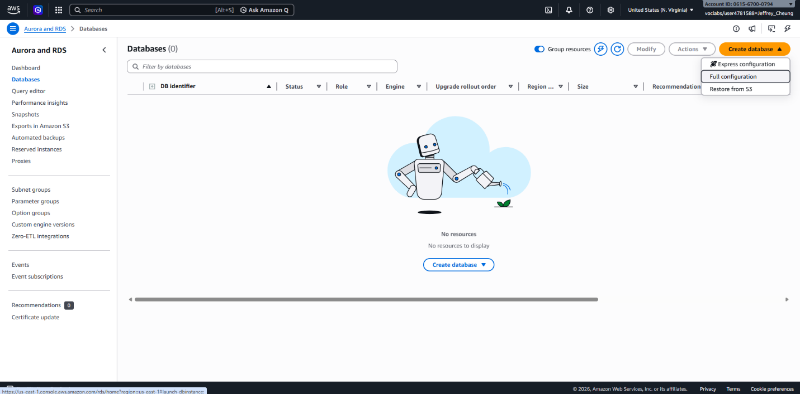
Go to Databases > Create Database.
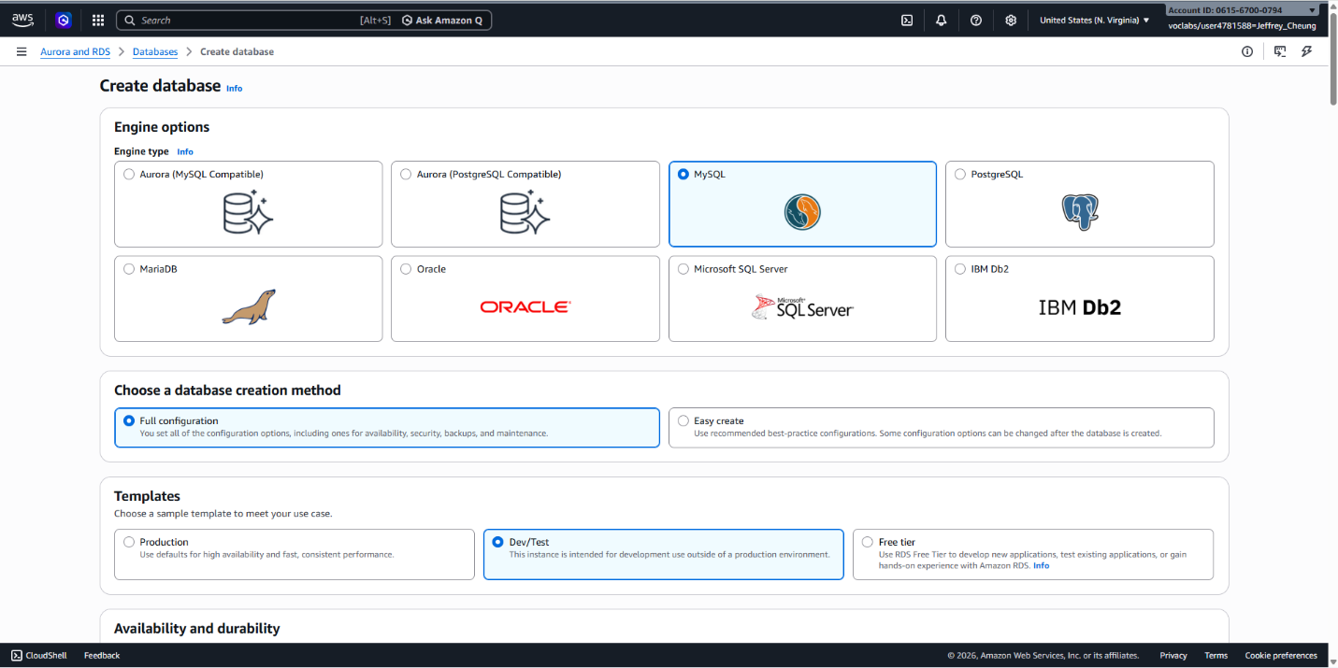
Set the engine type to MySQL. Set the template to Dev/Test.
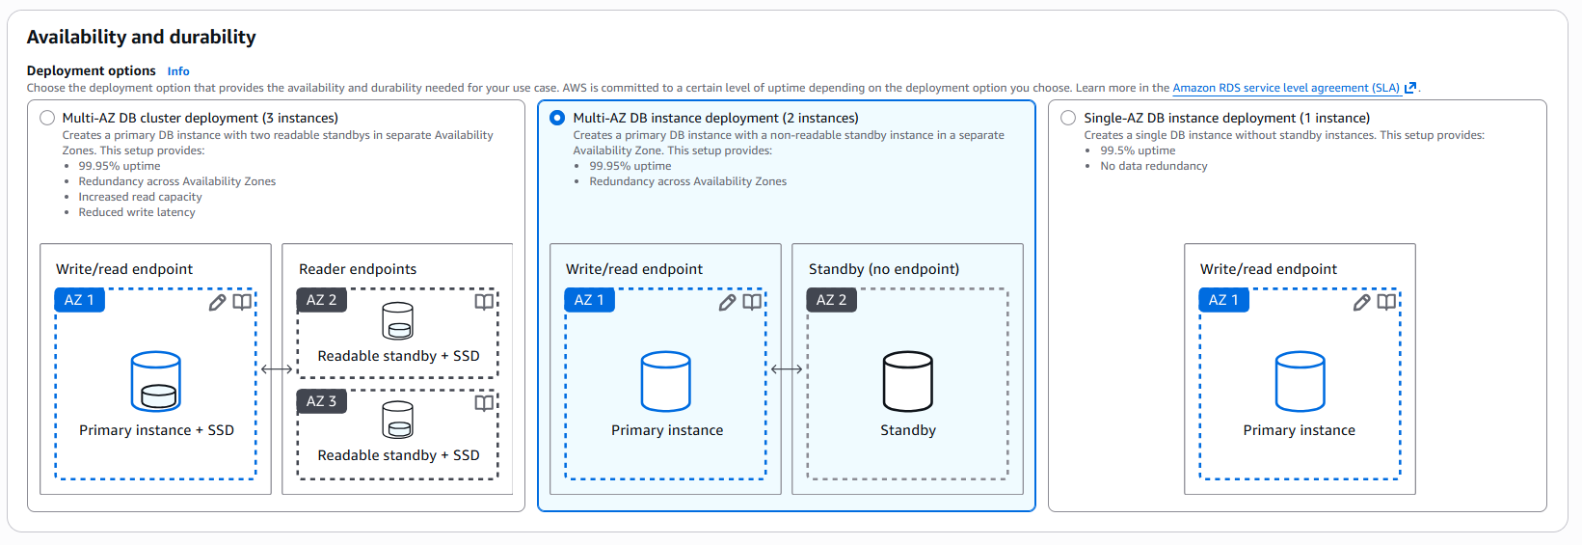
Set the deployment options to Multi-AZ DB instance.
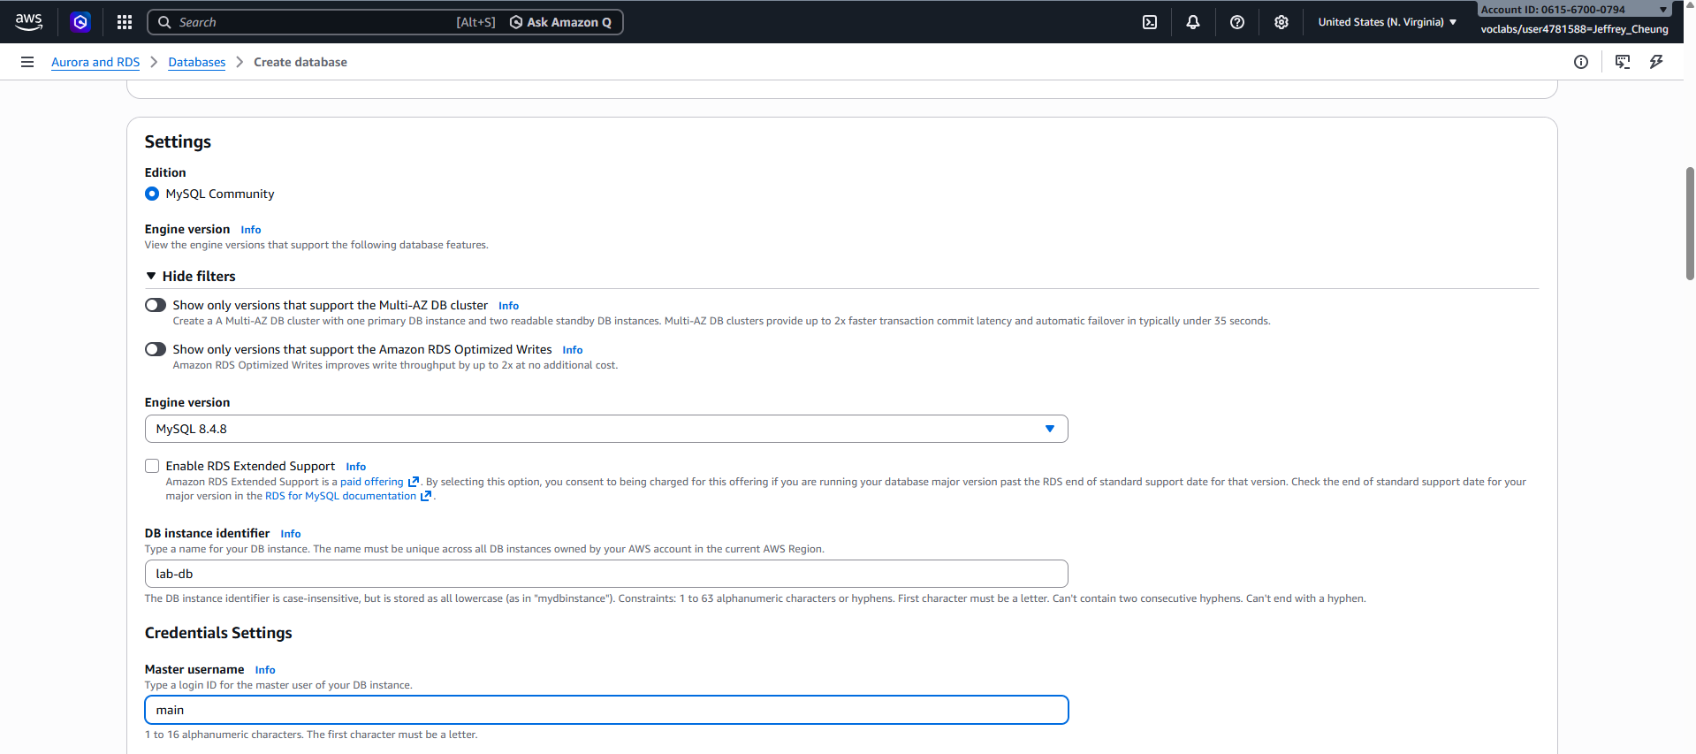
Set the DB instance identifier to lab-db. Set the master username to main.
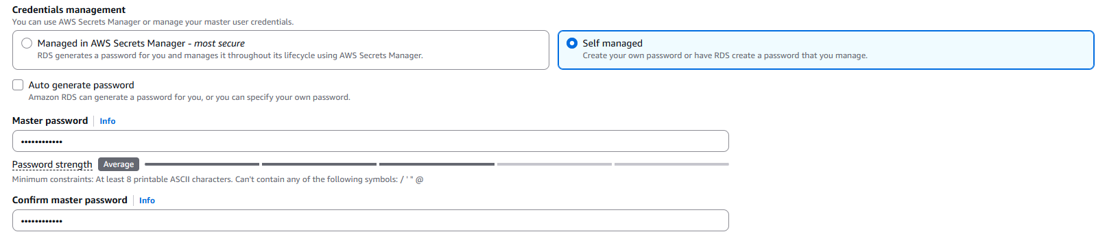
Set the credentials management to self-managed, and the master password to lab-password.
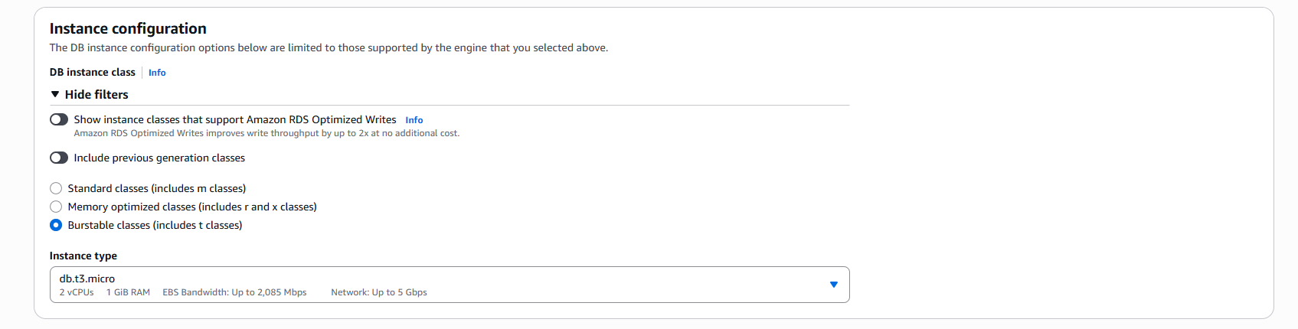
Under Instance configuration, set the instance class to Burstable classes, and select db.t3.micro.
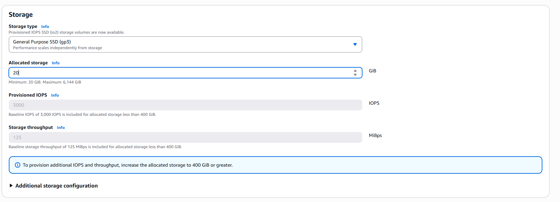 Under storage, set the storage type to General Purpose SSD and the allocated storage to 20 GiB.
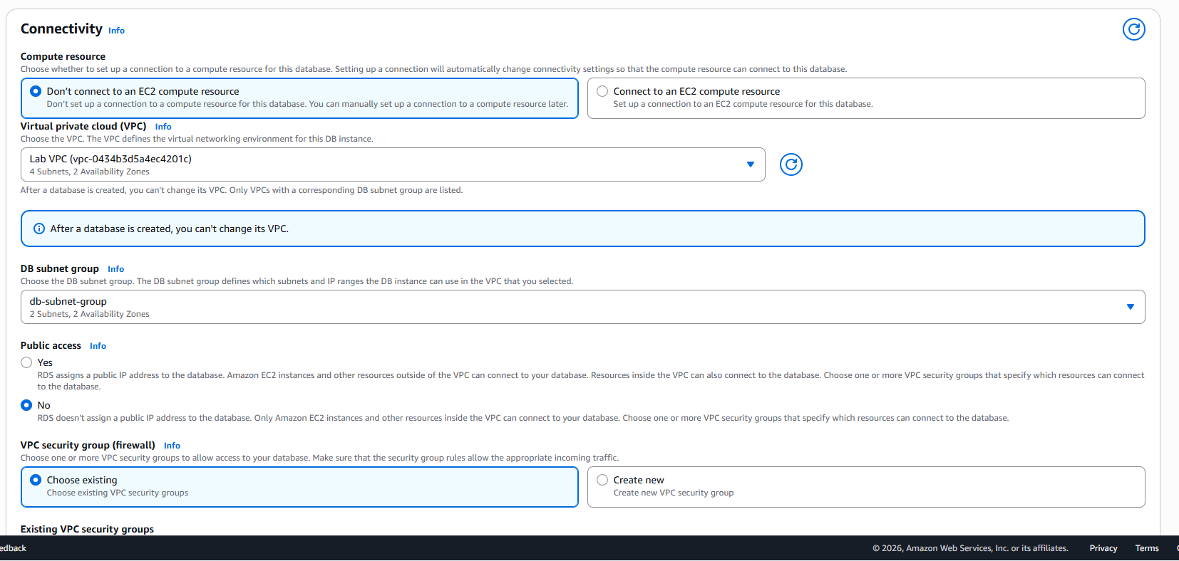
Under connectivity, set the VPC to Lab VPC.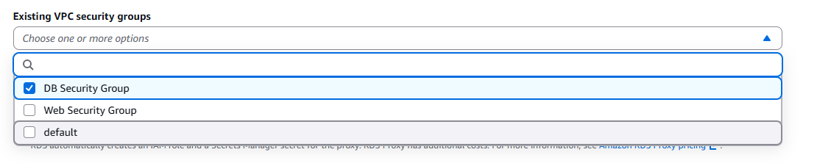
Set the existing security groups to DB security group.
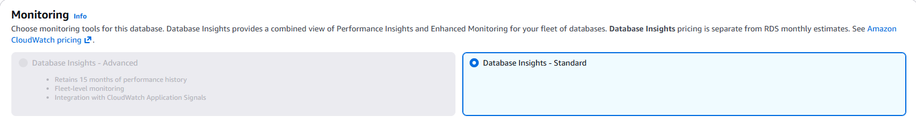
Under monitoring, set it to Standard.
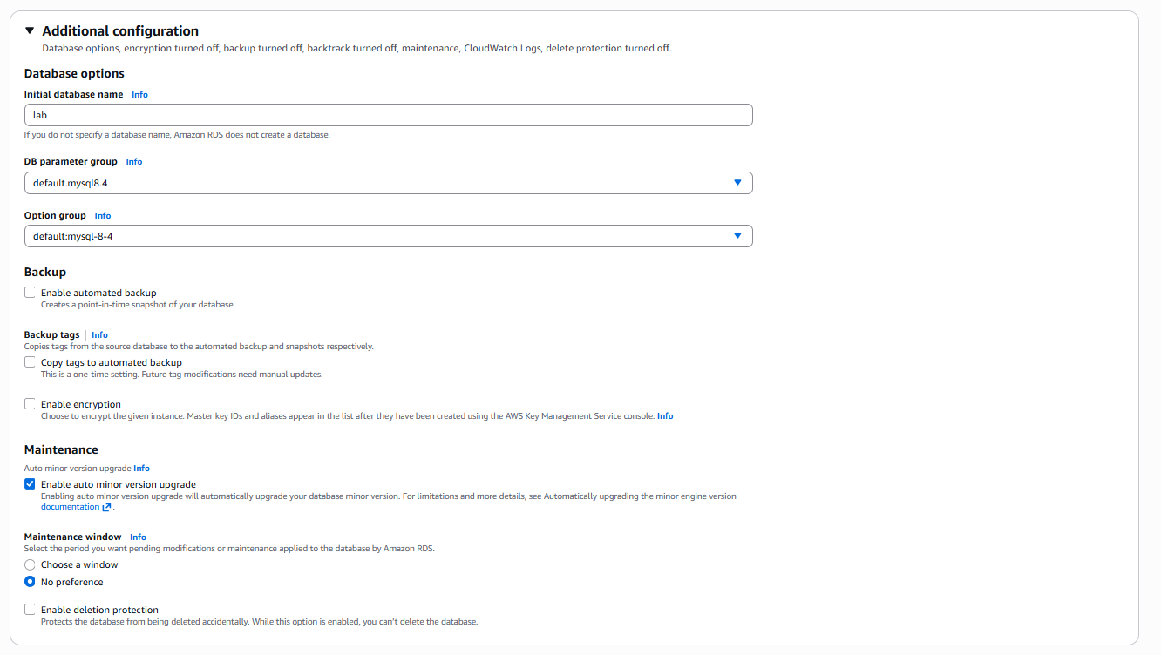
Under additional configuration, set the initial database name to lab, and disable automated backups and encryption
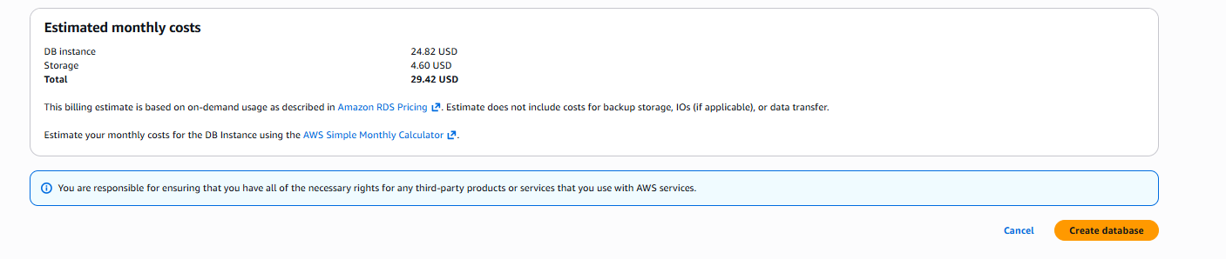
Click create database.
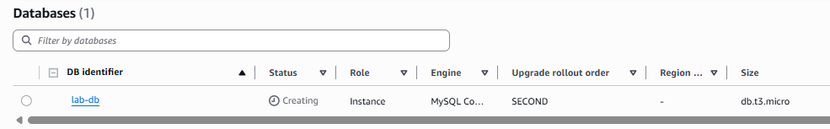
Click on lab-db.
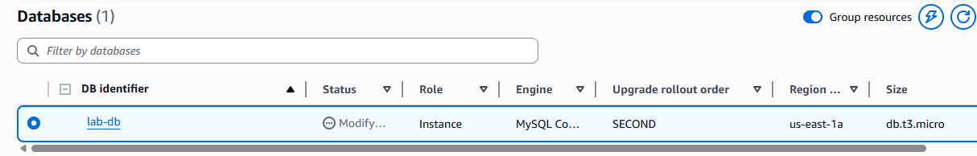
Wait until the status says Modifying or Available.
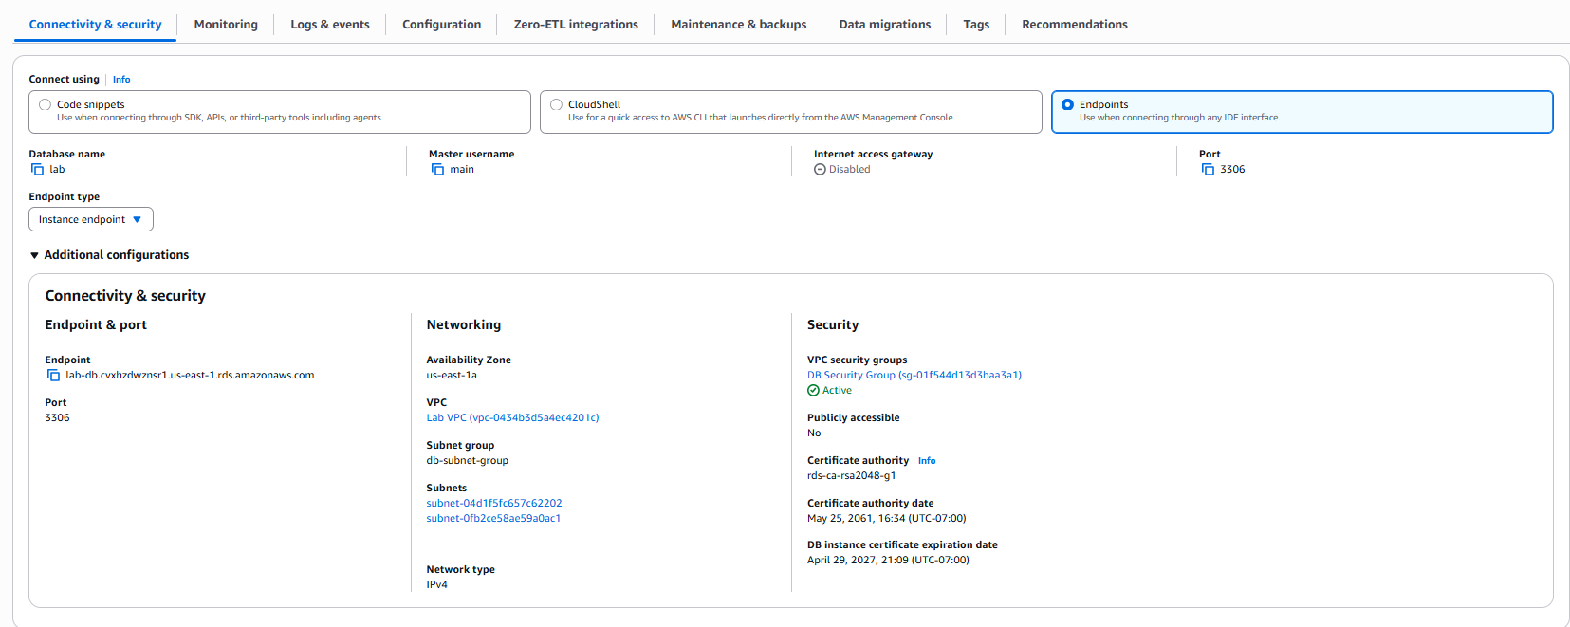
Scroll down to the Connectivity and security section and copy the Endpoint value.
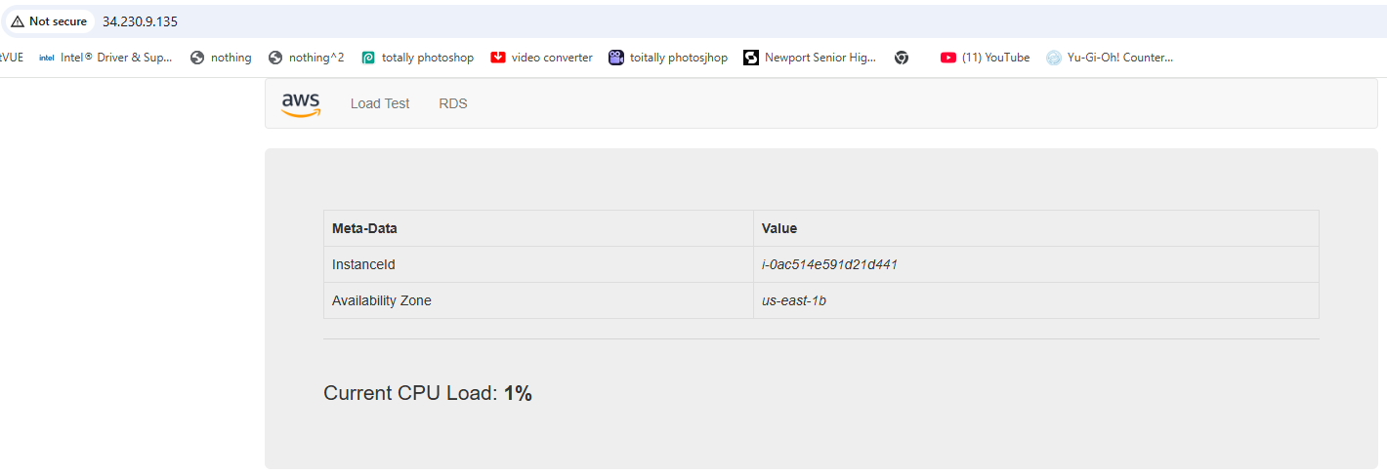
Connect to the Lab’s web server IP, and click on RDS.
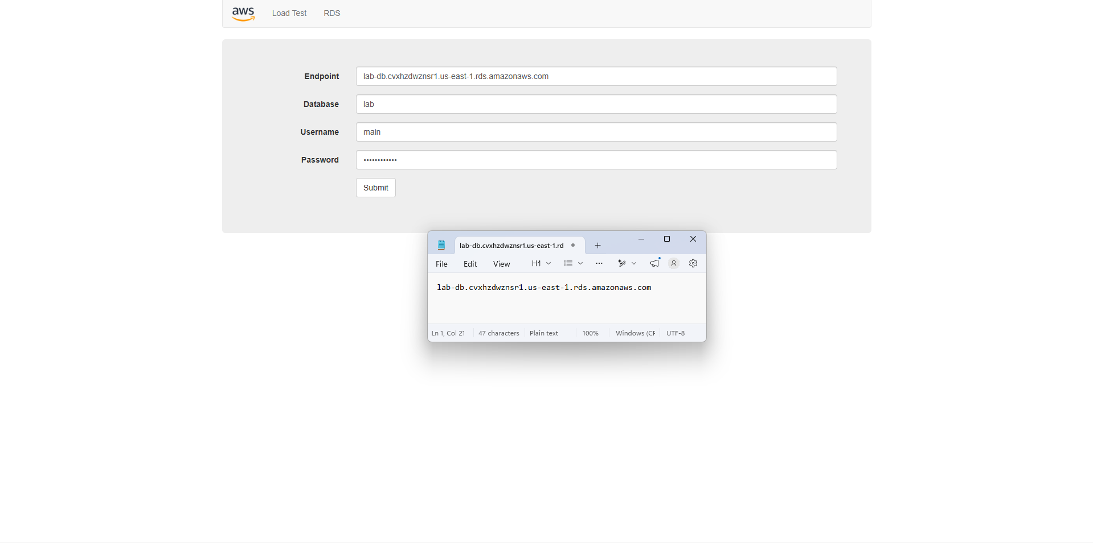
Paste the endpoint URL, and enter the database name, username, and password from earlier.
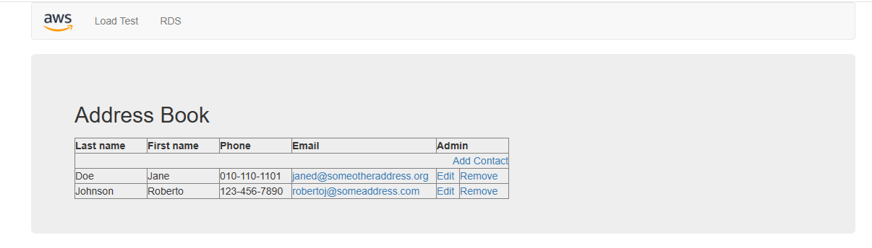
If done correctly, you should see an address book database. Click “Remove” to remove an entry.
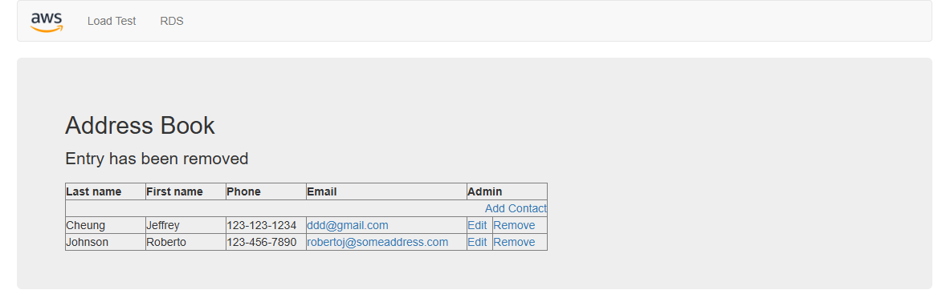
You should see a message saying that the entry has been removed. Next, click the “Edit” button next to the remaining entry.
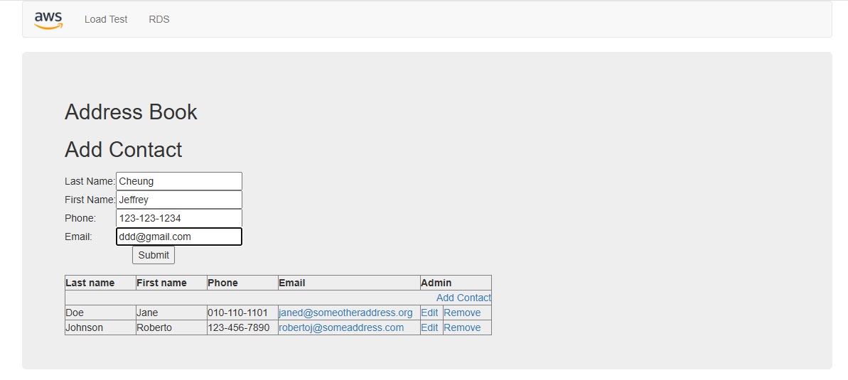
Change the details of the entry and click “Submit”.
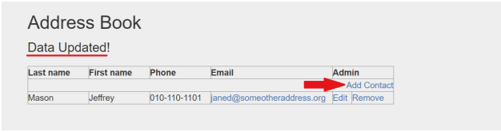
You should see a success message.
Auto Scaling (Lab 6):
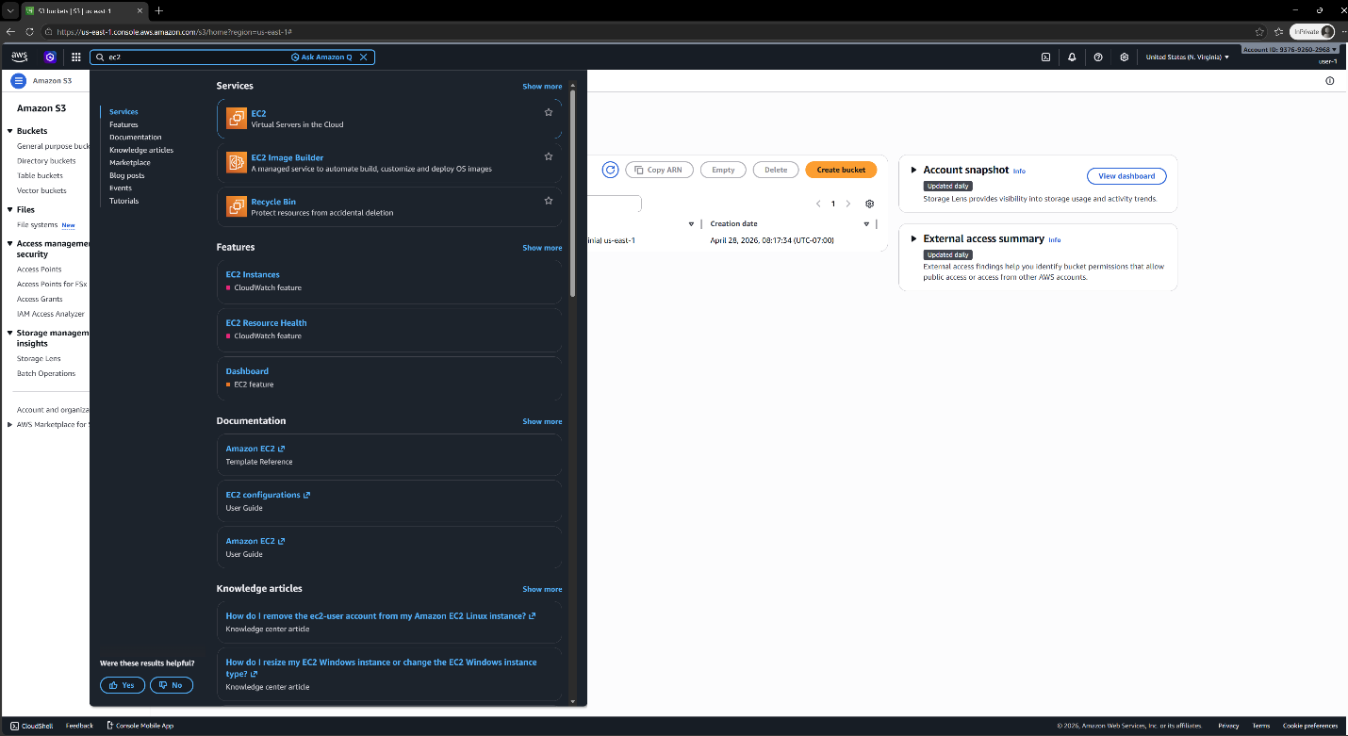
Go to the AWS management console and select “EC2”.

Problems:
Initially did not work
Conclusion:

